Group 9

Eric Garcia

Nathan Schapher

Eduardo Jimenez

1. Provide link to GitHub repository for TAs to view the code? (1 point)

* <https://github.com/Nate7204/4353Project>

1. Discuss if your design and development methodology has changed since assignment 1 and why? (1 point)

* We are using React App for building and deploying the website. Eric Garcia worked on the Login and Sign up pages, Nathan Schapher worked on the Fuel Quote Form and History, and Eduardo Jimenez worked on the Client Profile Management form.

1. List what front end technologies you are using and why. List who is responsible of doing what in your group? (2 points)

* We are using React App for building and deploying the website. Eric Garcia worked on the Login and Sign up pages, Nathan Schapher worked on the Fuel Quote Form and History, and Eduardo Jimenez worked on the Client Profile Management form.

1. Provide screen shots of your front end, each page? (5 points)

Login page

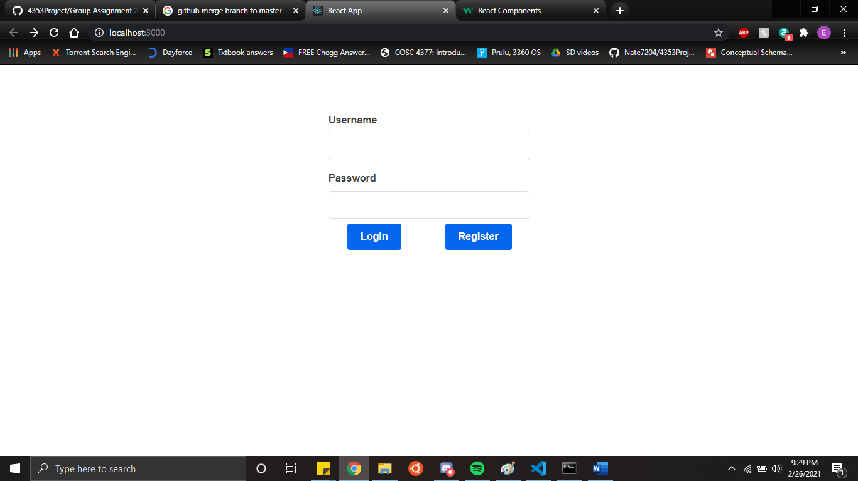

Register page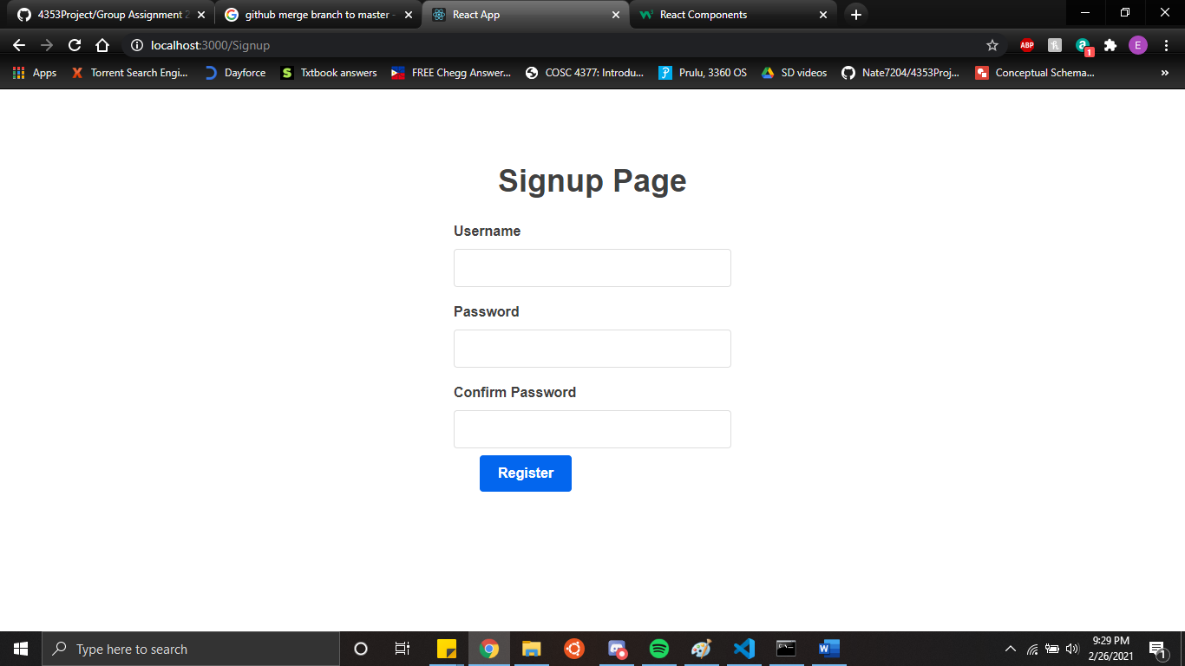

Profile Management page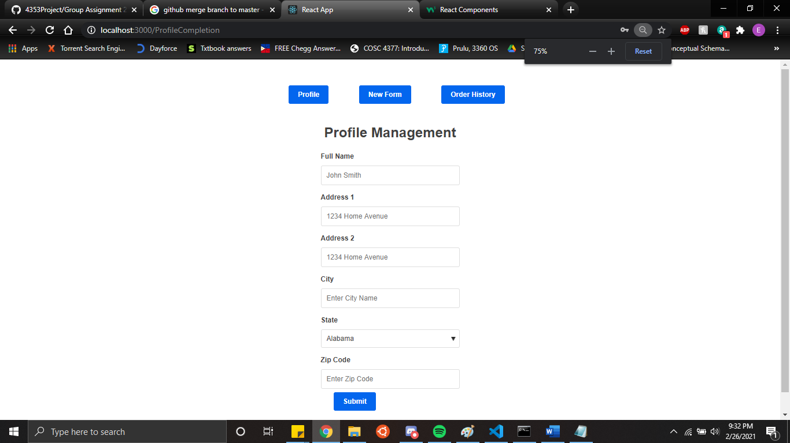

Fuel Form page:

Fuel History: 